Assiut University  Faculty of Science  Botany Department | 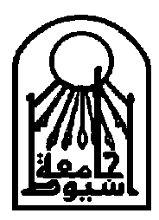 | جامعة أسيوط  كلية العلـوم  قسم النـبات
General Botany Exam.
for Pre-pharmacy Students, Jan. 2008
Time allowed: 3 hours 150 Marks

Section A: Plant Physiology (30 Marks)
Answer all of the following Four questions
1. Define Only Seven (one MARK(each) of the following terms:
a. True solutions b. Imbibitional force
c. Sol-gel transformation d. Osmosis
e. Adsorption f. Plasmolysis
g. Hydrophilic colloids h. cell turgor

2. Follow the -reactions of ONLY THREE (five Marks each) of the following:
a. Photosynthetic ATP synthesis
b. Pyruvate to acetyl CoA
c. No oxygen available for a plant cells
d. A competitive inhibitor of an enzyme

3. Write down the location of ONLY SIX (one Mark each) of the following processes:
a. Diffusion Pressure Deficit (DPD) b. Imbibition
c. Selective permeability d. Light reactions of photosynthesis
e. Dark reactions of photosynthesis f. Cytochrome chain
g. Glycolysis

4. Illustrate (diagram only) the relationship between osmotic concentration, diffusion pressure deficit, turgor pressure and cell volume in a flaccid cell placed in distilled water. (Two Marks)
Best wishes, Refat Abdel-Basset
Section B: Plant Morphology (30 Marks)
Answer the following questions:
a- Identify:
Pericarp - embryonic axis - cataphyll - calyptra - weak stem - veins - stilt root.
b- Write short notes on ONE only:-
1- Under ground modifications of stem. 2- Types of seed germination.
c- Illustrate only the followings:-
*Pneumatophores *Floating root *Foliar buds *Phylloclade stem.
Good Luck: Prof. Dr. K.A. Farghali
Section C: Plant Anatomy (30 Marks)
Firstly: Write brief notes with illustrations if possible on each of the following (15 Marks).
- Three types of a tissue of secondary origin help in support of woody plants
- Structure of a protective tissue of secondary origin
- Three types of simple unspecialized tissue
- Ergastic nitrogenous waste products
- Pits of water conducting elements
- Inulin OR Hydathodes
- Dendrochronology
- Callus and callose

Secondly: Answer ONLY THREE questions of the following: (5 Marks each).
1- What are the various criteria on the basis of which meristems can be classified? Give a brief account of various types of meristems based on any criterion? Mention the characteristic features of meristematic cells.
2- Describe different types of vascular bundles with well labeled diagrams. Give the examples of plants and their organs where these are found? Where does the interfascicular cambium occur?
3- Differentiate between heart wood and sap wood? Which of the two is more durable? Why? List the changes that occur during transformation?
4- Write short notes with illustrations on cell wall formation? Mention its chemical components.
5- Explain briefly ONE ONLY:
- How stomata are open when the guard cells are turgid?
- The process of secondary thickening in dicot roots with a labeled diagram
Good Luck; Prof Dr. M. A. El-Nagdy
Section D: TAXONOMY (30 Marks)
First question: (6 marks each)
- Define (hypogenous flower, persistent calyx, syngenesious, apocarpous)
- Draw a labeled diagram showing the generation of male gametes
- Compare between legume and siliqua, give an example to each.
- Compare between Solanaceae and Papaveraceae in (sepals & petals).
- Enumerate one botanical name and its importance belonging to:
Liliaceae, Brassicaceae, Caesalpiniaceae, Fabaceae, Poaceae & Asteraceae

Second question: (6 marks each)
- Give 4 different types of racemose inflorescence with illustration.
- Name 3 different systems of classification. Give examples.
- Compare between Cyperaceae and Gramineae in (leaf &' fruit).
- Describe the floral characteristics of Apiaceae with floral diagram.
- Give 3 botanical names and families of ornamentals and 3 of medicinals.
Good Luck Prof Momen Zareh

First Semester Final Examination
Botany: (Mycology and Phycology)
Pre-Pharmacy Students January 2008
في كراسة الإجابة أنشئ جدولا من عمودين موضحا بأحدهما أرقام الأسئلة وبالآخر الإجابة المطلوبة:
Choose the correct answer (All questions should be answered
Total marks = 30 (one mark for each question)
1- Antibiotics produced by fungi Include:
a- Penicilllns b- Gluconic acids c - Vitamins
2- Some algae and fungi exist In a mutualistlc mode of living forming:
a- Mycorrhizae b- Plasmodia c- Lichens
3· -Antherldia and oogonla are sexual structures produced by:
a- Ascomycota b- Zygomycota c- Oomycota
4- When consumed by man and animals, Claviceps purpurea can cause:
a- Lung aspergillosis b- Club root c- Ergotism
5- Carcinogenic metabolites produced by some Aspergillus species:
a- Griseofulvin b- Ethanol c- Aflatoxins
6- Cholesterol lowering drugs can be produced during fermentations done by:
a- Aspergillus terreus b-Phytophthora c- Plasmopara
7 - Used commercially for processing good quality of ripened cheese:
a- Pellicillium roqueforti b- Albugo c- Agaricus
8· Fungal cells have distinct cell walls but they do not contain:
a- Nuclei b- Mitochondria c- Chloroplasts
9· Sexual reproduction in Rltizop"s results in the formation of:
a-Zygospores b- Sporangia c- Zoospores
10· Griseofulvin Is an antibiotic effective against:
a- Dermatophytes b- Candida c- Aspergillus infection
11- Plants grow better when they are inoculated with:
a- Rhizopus b- Claviceps c- Mycorrizal fungi
12· Saprolegniasls is a fungal Infection affecting:
a- Grapevine leaves b- cabbage roots c- Fish and fish eggs
13- Ethanol is produced during fermentation of sugars by:
a-Saccharomyces cerevlslae b- Pythium c- Penicillium
14- Used in traditional chinese medicine for treatment of various diseases: ..
a- Cordyceps b- Candida albicans c- Trichophyton
I5-Used in some countries as a good source of proteins and vitamins:
a- Spirulina b- Diatoms c-Nostoc
16- In Spirogyra, sexual reproduction is commonly observed as:
a-daughter cells b- Sscalariform conjugation c- Pycnidia
======================(Please see next page)=======================
17- Asexual reproduction in Volvox occurs by formation of:
a- Buds b- Antheridia c-Daughter colonies
18- Which of the following is regarded as an advanced colony:
a- Volvox b- Chlamydomollas c- Oscillntoria
19- Sexual reproduction in Fucus occurs by:
a- Daughter colonies b- Antheridia and oogonia c- Daughter cells
20- Agar agar is produced from:
a- Spirogyra b- Diatoms c- Red algae
21-ln Euglena, food is reserved in the form of:
a- Laminarin b- Paramylon bodies c- Oil
22- Used commercially for production of seaweed soap and skin care cosmetics:
a- Cyanophyta b- Brown algae c- Euglella
23- Phycoerythrin is the most dominant pigment in: .
a- Rhodophyta b- Phaeophyta c- Euglenophyta
24-Very important in water purification and food supplementation:
a- Microcystis b- Cltlorella c- Spirogyra
25- Provided with two anterior flagella
a- Oscillatolria b- Cltlamydomonas c- Diatoms
26- Unicellular alga without cell walls:
a- Nostoc b- Euglena c- Lamiflaria
27- In Phaeophyta food is preserved in the form of:
a- Floridian stach b- Laminarin and mannitol c- Oils
28- Perithecia are fungal structures containing:
a- Conidia b- zoospores c- asci amI ascospores
29- Plasmodiophora brassicae is the causal agent of:
a- Club root of cabbage b- fruit rot c- Lung aspergillosis
30- Several fungi produce acervuli and pvcnidia which contain:
a- Ascospores b- Basidiospores c- Conidiophores and conidia

=========================== THE END==========================

Best wishes, Professor Ahmad M. Moharram

Assiut University  Faculty of Science  Botany Department | بسم الله الرحمن الرحيم | جامعة أسيوط  كلية العلـوم  قسم النـبات
General Botany Exam.
for Pre-pharmacy Students, Feb. 2008
Time allowed: 3 hours

Section A: Plant Physiology (30 Marks)
Write on Three only: (10 marks for each)
1- Light reaction
2- Krebs cycle.
3- Respiratory chain.
4- Mobilization of glycerol.
5- The biosynthesis of fatty acids.
Prof. M. Abdo Shadad
-----------------------------

Section B: Plant Anatomy (30 Marks)
Answer only Five questions of the following:- (6 marks for each)
1. What are the characteristic features of meristematic cells? Give an account of various types of meristems based on their position.
2. Give an illustrated account of various types of vascular bundles.
3. What is the origin and function of sclerenchyma'! Describe with illustrations various types of sclereides.
4. Describe briefly the various types of parenchymatous tissue? Also, describe various types of pits found in this tissue.
5. Why seive tube loses its function? Write on its structural adaptation to function.
6. Describe the process of formation of annual rings?
7. Write short notes with illustration on cell wall formation.
Prof. M. M. El-Nagdy
Section C: Fungi and Algae (30 Marks)
Firstly: Write brief notes with illustration if possible on Six only of the following:- (2 marks for each)
Akinetes - Ani sogamy - Aflatoxins - Ergotamine - Mycorrhizae Pycnidium - Chlamydospores - Compound zoospores.
Secondly: Discus briefly Three only of the following: (6 marks for each)
1. Classification of Eumycophyta (true fungi), show the basis of classification with
the help of drawing.
2. Various types of sexual sporocarps.
3. The bases on which, the algae are classified into various divisions.
4. Structure and economic importance of Yeast.
5. Varios mode of life (nutration) in Fungi.
Prof. M. A. El-Nagdy
-----------------------------

Section D: Taxonomy of Flowering Plants (30 Mlarks)
Answer Five only of the following questions:- (6 marks for each)
1. Define:- hypogenous flower, deciduceus calyx, syngenesious & syncarpous
2. Draw an illustration showing 3 types of racemose inflorescence.
3. Compare between drupe & berry, give an example to each.
4. Compare between Prunoideae and Pyroideae in (carpels & fruit).
5. Give 1 botanical name & family of vegetable, pulse, cereal & medicinal plant
6. Describe the floral characteristics of family Papaveraceae with floral diagram. Enumerate 2 of the important plants.
Prof. Momen Zareh

Assiut University  Faculty of Science  Botany Department | بسم الله الرحمن الرحيم | جامعة أسيوط  كلية العلـوم  قسم النـبات
General Botany  Time allowed: (3) hours | Second Term Examination (June 2008)  Pre-pharmacy تخلفـات
Answer all the following questions:
Section A: Plant Physiology (30 Marks)
1. Write on FIVE only of the following:
a) Light reaction.
b) Krebs cycle.
c) Nitrate reductase enzyme.
d) Dark reaction.
e) Respiratory chain.
f) The biosynthesis of fatty acids.
g) Symbiotic nitrogen fixation.
Prof. Dr. M. Shadad
Section (B): Plant Morphology & Anatomy (50 marks: 10 each)
2. Using illustration (if possible) discuss FIVE ONLY of the following:
a) Adaptation of structure of xylem tissue to its function.
b) Types of RNA's and their role in protein synthesis.
c) Different types of vascular bundles.
d) Leaf modifications with special reference to insectivorous plants.
e) Characters and shapes of Collenchyma cells.
f) Types and distribution of stomata.
g) Requirements of seed germination.
Prof. Dr. A. M. Moharram
Section (C): Plant Kingdom (50 marks: 10 each)
3. Answer FIVE ONLY of the following:
a) Enumerate the various classes of fungi. Give with the help of drawing two distinctive features of each class. Show the basis of classification.
b) What is the causal organism of the black rust disease? Describe with the help of drawing the various types of spores produced by the fungus on its primary host (wheat).
c) Prepare a diagrammatic representation of alteration of generation in archegoniates. Also, discuss briefly with drawing Adiantum gametophyte.
d) Discuss briefly lytic life cycle of virulent phage.
e) Discuss briefly the auxospore formation by algae.
f) Write brief notes on the bases on which algae are classified into various divisions.
g) Illustrate diagrammatically and comment on asexual reproduction in Clamydomonas OR Vaucheria.
Prof. Dr. M. A. El-Nagdy
The Plant Morphology
Pre-Pharmacy Students (تخلفات)
Answer the following questions: (30 marks)
****************************************
A- Complete:
I-The pericarp is ………………………………………………………………………
2- Endospermic seed has ………………………… which is stored the food.
3- Cotyledon functions are ………………., ………………., and ……………………...
4- Root cap is called ………………………………………………………………….....
5- Coleoptile means …………………………………………………….
6- foliar bud is developed from …………………………………….
7- ………….…… and ……………………….. are negative geotropic roots.
8- Adventitious buds are originated from ……………………………………………
9- Trailing stem is spread on the ground without ……………………….. at nodes.
10- Cladode is a phylloclade but has ……………………………….. internodes.
11- The functions of petiole are …………………….. and ……………………..
12- Branch has …………..…….. bud and compound leaf has ....................... bud.
13- Mechanical donnancy is caused by …………………….
-----------------------
B- Correct the word between bracts:
1- (Tegmen) ........... is a thick seed coat enclose the embryo.
2- In grain, the endosperm (envelope) ……………….. the embryo.
3- Seeds are (vegetative) ………………. reproductive organs.
4- Immaturity of embryo is due to (physical) ……………….. dormancy.
5- During germination, starch is converted to glucose by lipase) ……………
6- Secondary roots are originated from (endoderm is) ……………………………..
7- Swollen root without definite shape is called (napiform) ………………………
8- Clinging roots are related to the (floating) ……………………… roots.
9- Winter buds are protected by (sporophyll) …………………………. leaves.
10- Runners are plants grow (vertically) ………………………. all the ground.
11- When (branch) ............................... falls, it leave a scare.
12- In (pinnate) ……………… venation lateral veins run toward leaf Margin.
13- Root hairs are (multicellular) ……………………………………..
-----------------------
c- Illustrate only each of the followings:
1- Durian germination. 2- Pneumatophores. 3- Prop root.
4- Radicale buds 5- Cladode 6- Phyllotaxy.

Prof. K.A. Farghali

Faculty of Science  Department of Zoology  Exam: Zoology for Prepharmacy  Code: |   كلية العلوم – قسم علم الحيوان | امتحان الفرقة: إعدادى صيدلة  المقرر: علم الحيوان  رقم المقرر ورمزه:  الزمن: ثلاث ساعات  24 يناير 2008
Taxonomy
I-Choose the correct answer: (20 marks)
1- Ascaris is an ideal example of (molluscans – chordates – nematodes).
2- Protista includes (cellular organisms – parazoans organisms – acellular organisms).
3- Common names of animals are usually used for (scientific – inrernational – local purposes).
4- commensal organisms are usually (harmful – helpful – harmless).
5- ptotozoans nutrition type is (autotrophic – heterotrophic – saprozoic – all)
6- Polyp and medusa are forms of (nematodes – annelids – cnidarians).
7- Annelida, Mollusca, Chordata are (coelomafephyla – major phyla – both).
8- The infective stage of Taenia is (Leptocercus – Lophocercus – Cysticercus).
9- Entamoeba histolytica, is a human parasite lives in (mouth – eyes – intestine)
10- Cilia – Podia – flagella are (respiratory – excretory – locomotary organelles).
11- High diversity of Arthropods is due to (exoskeleton – jointed legs – segmentation – all).
12- Insects characterized by (4paires – 2 paires – 3paires of legs).
13- Scorpions attribute to (worms – insects – arachnids).
14- Nematocysts are cnidarian's cells found in (endoderm – mesoderm – ectoderm).
15- The intermediate host snail of Fasciola is (Bulinus – Pirenella – Lymneae).
16- Respiration of cestodes takes place by (respiratory system – binary fission – simple diffusion).
17- Hirudun, is a substance secreted by leeches as blood (coagulant – aggulant – anticoagulant).
18- Circulatory system was firstly appearing in (nemalodes – chordates – annelids).
19- Pearls, both natural and cultured, are produced by (snails – leeches – bivalves).
20- One of the following organs is not related to others (flame cell – green gland – radula).
II-Put √ or X for each of the following: (20 marks)
1- Coanocytes are specialized cells have sting organelle used for defence ( ).
2- Locomotary organelkles used as a taxonomic character to classify cnidarians ( ).
3- Fertilization of gametocytes of Plasmodium usually occurs in human blood ( ).
4- Nematoda considered the first animal phylum has digestive tract ( ).
5- Pseudocoelum is a secondary body cavity found in the mesoderm ( ).
6- Coxal and green glands are organs of respiration in arthropods ( ).
7- Heterophyes worms are usually distributed in upper Egypt ( ).
8- Lophocercus cercaria has only cystogenus glands ( ).
9- The final host is the animal where the adult parasite live in it ( ).
10- Each egg if Schistosoma worm gives digestive tract ( ).
11- Taenia sp. Is a parasite without digestive tract ( ).
12-Nephredium is an excretory unit of Annelida ( ).
13- All trematodes are hermaphrodite ( ).
14- Leeches considered coelomate animals ( ).
15- The species is a group of similar animals ( ).
16- Radula is a rasping organ in molluscans ( ).
17- The insects attribute to Arthropoda ( ).
18- Ascar is has a direct life cycle.
19- Scyphozoa is a class attributes to cnidarians ( ).
20- Plasmodium causes the malaria fever ( ). انظر خلفه
Draw labeled diagrams for the following twins: 20 marks
A nematocyst | A choanocyte
An excretory unit of Fasciola | An excretory unit of Hirudo
A trematode cerxaria that infects human | A cestod cercaria that infects human
Coelomate animal | Acoelomate animal
Cytology
22 marks
I- Choose the correct answer:
1- Binary fission is a process division in:
a) eukaryotic cell b) prokaryotic cell c) mesokaryotic cell
2- The separation of the duplicated genome into two sets (mitosis) occur in the:
a) cytoplasm b) nucleus c) cytosol
3-The point where microtubules of the spindle apparatus attach with the chromosome is:
a) centriol b) kinetochore c) aster
4- The chromosomes migrate to the equator of the spindle in the:
a) telophase b) metaphase c) prophase
5- Maiosis I known as: a) duplication b) reduction c) division
6-The centromeres still intact in: a) anaphase II b) anaphase I c)metaphase I
7- The participation of the membranous organelles in cellular metabolism is:
a) indirect b) direct c) both
8- In the amphipathic molecules of phospholipids, the head linked to tail by:
a) phosphate group b) sulphate group c) carbonate group
9- Genetic abnormalities of spectrin structure lead to:
a) anaemia b) membrane fluidity c) membrane transport
10-In active transport, the molecules moves from area of:
a)high concentration to one of low concentration b) low concentration to one of high concentration c) no concentration difference
11-The organelle which facilitates absorption and form the striated border in the intestine is:
a) microvilli b) microtubules c) microfilaments
12-In muscle cells, the SER is a specialized form and known as:
a) sarcoplamic reticulum b) neuroplasmic reticulum c)ergastoplasmix reticulum
13- Each centriole duplicates itself at: a) the beginning of cell division
b) the end of cell division c) middle of cell division
14-Exogenous pigments include: a)minerals b) melanin c) lipofuscine
15-Recognition of nerve cells for other nerve cells during synaptic formation is called:
a) microenvironment b) antiginicity c) molecular recognition
16- The pores of the cell membrane are lined with:
a)glycoprotein b) phosphlipid c) protein layer
17- SER involved in the breakdown of glycogen due to the presence of certain enzyme which one of the following: a) acid phosphatase
b) alkaline phosphatase c) glucose-6-phosphatase
18- The phase of Golgi apparatus which receives the transfer vesicles from the RER is called:
a) granular phase b) mature phase c)immature phase
19-The lysosomes are present in almost all cells, but they are particularly abundant in:
a) muscle cells b)liver cells c) phagocytic cells
20-Ribosomes are composed of almost 80 different proteins and: a)20 types of ribosomal RNA b) 8 types of ribosomal RNA c) 4 types of ribosomal RNA
21-The distance between the outer and the inner membranes of mitochondria is called:
a) intercristal space b) intermembrane space c) intermembrane space
22- RER is prominent in the cells specialized for:
a) lipid synthesis b) lipoprotein and steroid c) protein synthesis

II- Label the following diagram: 8 marks
1-
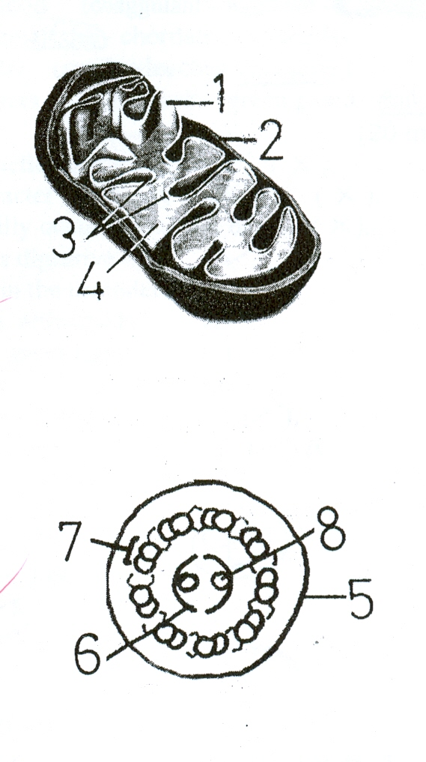
2-
3-
4-
5-
6-
7-
8-

Assiut University Jan. 2008
Faculty of Science
Chemistry Department Time allowed: 3 hrs.

Examination of Physical and Inorganic Chemistry for Pre-Pharmacy Students
Section (I)
Answer Three Only of the following: (50 Marks)
1) a) Discuss the kinetics for the following reactions:
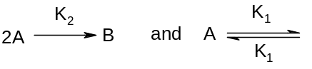
where K₂ is the rate constant for a second order reaction and K₁ , K ^{-I} represent the values for first order kinetics.
b) Derive the following thermodynamic relations:
(i) Volume arid temperature in adiabatic processes.
(ii) Entropy change and temperature for processes carried out either at constant volume or constant pressure.

2) a) Discuss the effect of temperature on reaction rate.
b) Write a brief account on the followings:
(i) Standard cells. (ii) Calomel electrode.
(iii) Reversible and irreversible cells and
(iv) Measurement of single electrode potential.

3) a) Derive an expression for the efficiency of heat engine working between two
temperatures T₁ and T₂.
b) The half life periods for a certain reaction at different initial concentration are
given below:
Initial concentration  Mole/liter | 0.20 | 0.15 | 0.10 | 0.05
t½ Time/min. | 5 | 6.66 | 10 | 20
Calculate the reaction order and the rate constant.

4) a) One mole of water vapour is condensed at 100°C and the water obtained is cooled at 0°C and then frozen to ice. Calculate the entropy change for the process. Latent heat, of·;fusion and vaporization of ice and water are 80 and 540 cal. per gm, respectively, also the heat capacity for water = 1.01 cal.gm-^{t} K-¹,
b) For certain gas C_{p} = 12.0 cal. mo'r¹ K-¹, what will be the change in entropy of 10 moles of the. gas when it is expanded from a volume of 200 Iiters at 3 atm. pressure to a volume of 400 Iiters at 1 atm. pressure. Calculate also ΔE, ΔH and W for the process.
أنظر خلفه باقي الأسئلة
Section (II)
Answer Three Only of the following: (75 Marks)
1) a) (In S.I units) what is the frequency and wave number associated with light of wavelength equals to 6000A°? (c = 3 xl0⁸ m.s⁻¹).
b) (i) Give an experiment how to obtain the line spectrum of hydrogen atom.
(ii) Calculate the wave number of the third line in Brackett series (R = 109678 cm⁻¹).
2) a) What is the wavelength of a grain of sand that weighs 0.000010 g and is moving at a speed of 0.010 ms-¹ (h = 6.63 X 10⁻³⁴ Js, 1 J = 1 Kg m²/s²).
b) Give reasons for:
(i) Atomic radii of the representative elements decrease across a period from left to right.
(ii) Why the Cl atom does not form a C1²⁻ ion instead of the Cl⁻ ion? (Crystal lattice for Na₂Cl = ∼ - 2570 kJ/mol, for NaCl = -789 kJ/mol).
(iii) Electron capture (in β-decay) is accompanied by production of X-rays.
3) a) Write on:
(i) Isotopes application in studying photosynthesis and in medicine.
(ii) BeCI₂, BCl₃, PCl_{3s} and SF₆ as examples of exceptions to the octet rule.
b) Give the nomenclature of: [Ag(CN)2]⁻, [Cr(NH₃)₃Cl₃], [Co(NH₃)₄Cl₂]⁺
4) a) Draw the molecular orbital energy-level diagrams for: O₂+ , O₂ and O₂⁻², which of the three are paramagnetic or diamagnetic?
b) Deduce the Lewis structure of CO₃²⁻
Section (III)
Answer Four Only of the following: (25 Marks)
1) Describe how the surface tension of liquid can be determined by the capillary rise method.
2) How many g of oxygen is contained in 10.5L of oxygen measured over water at 25°C and 740 mmHg? Vapour pressure of water at 25°C is 24 mmHg.
3) Derive the relationship between K_{c} and K_{p} for a reaction:
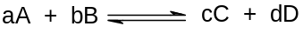
4) a) What are the fundamental assumptions of the kinetic theory of gases?
b) Derive.Avogadro's law from the kinetic gas equation.
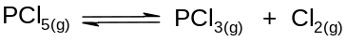
5) For the reaction:
pure PCl_{s} is introduced into evacuated chamber and allowed to equilibrium at 250°C and 2 atm. The equilibrium gas contains 40.7% chlorine by volume. Calculate K_{c} and K_{p} for the former reaction.

Atomic masses (H= 1, C= 12, Cl= 35.5, O= 16, P= 31)

Good Luck
Department of Mathematics  Faculty of Science  دور يناير 2008م  الزمن: ساعتان |  | قسم الرياضيات  كلية العلـوم  أمتحان الفرقة: إعدادي صيدلة  إسم المقرر: رياضيات وإحصاء

أجب عن الأسئلة الآتية:
السؤال الأول: (10 درجات)
أ) أوجد 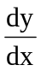 لكل مما يأتي:
(i) y = cosec (5x) + e^{cot (2x)}
(ii) y = 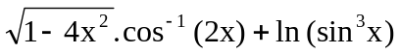
ب) إذا كانت 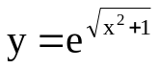 فإثبت أن 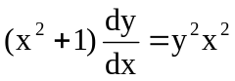
ج) أوجد من العلاقة الآتية: sin y = cos (x – y)

السؤال الثاني: (10 درجات)
2-أ) أحسب ثلاثة فقط من التكاملات الآتية:
(i) 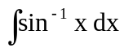 , (ii) 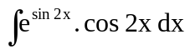
(iii) 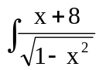 , (iv) 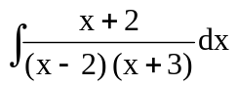
ب) أوجد القيم العظمي والصغري المحلية للدالة:
f (x) = 4x³ + 6x² – 24x + 30
ج) أوجد صيغة اختزالية للتكامل الآتي: 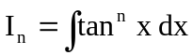
ومن ثم أوجد قيمة 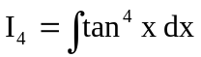

السؤال الثالث: (15 درجات)
أ) أوجد قيمة لكل من µ , λ التي تجعل للنظام
x + 2y + 3z = 5 , x + 3y + 5z = 9 , x + 3y + λz = µ²
(i) حل وحيد ثم أوجده (ii) عدد لانهائي من الحلول ثم أوجد إحداها.
ب) استخدم طريقة نيوتن رافسون في إيجاد قيمة تقريبية للمقدار 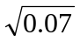
السؤال الرابع: (15 درجات)
أ) البيانات التالية تمثل علاقة بين المتغيرين y , x
x | -2 | -1 | 0 | 1 | 2
y | 8 | 4 | 2 | 2 | 4
(i) أوجد أفضل قطع مكافئ يقرب مجموعة هذه البيانات باستخدام طريقة المربعات الصغري.
ثم أوجد قيمة y عند x = 10.
(ii) أوجد معامل التحديد ومنه استنتج قيمة معامل الارتباط. وما هي النسبة المئوية للتغير الذي يفسره الانحدار ؟
ب) إذا قيست كمية الصوديوم في عينتين من علب العصير الموجودة بالأسواق لنوعين من العصير (التفاح والبرتقال) وكانت النتائج كما في الجدول:
التفاح | 4.86 | 5.11 | 5.23 | 5.14 | 5.61 | 5.32
البرتقال | 4.72 | 4.81 | 5.22 | 5.67 | 5.52 | 5.35 | 4.41 | 5.50

أختبر الفرض القائل بأن هناك اختلاف بين متوسط كمية الصوديوم في هذين النوعين من العصير عند مستوي معنوية α = 0.05.
(استخدم ما يلزم من القيم (t (0.975; 12) = 2.18 , Z_{0.975} = 1.96

أنتهت الأسئلة مع تمنياتنا بالنجاح والتوفيق ،،،،

Assuiut University الإمتحــان وجهـــان January, 2008
Faculty of Arts Time: 2 hours
Dept. of English
First Semester -- Final Exam
Subject: No. …………………. English Language
Students: Preparatory Year - Faculty of Pharmacy
I- Write a paragraph of TEN lines on only ONE of the following: [10 marks]
1- Drug addiction 2- Pollution 3- The importance of a pharmacist in society
II- Read the passage and choose the best answer (a, b, c, or d): [9 marks]
The earliest authentic works on European alchemy are those of the English monk Roger Bacon and the German philosopher S1. Albelius Magnus. In their treatises they maintained that gold was the perfect metal and that inferior metals such as lead and mercury were removed-by various degrees of imperfection from gold. They further asserted that these base metals could be transmuted to gold by blending them with a substance even more perfect than gold. This elusive substance was referred to as the "philosopher's stone." Most' of the early alchemists were artisans who were accustomed to keeping trade secrets and often resorted to cryptic terminology to record the progress of their work. The term sun yvas used for gold, moon for silver, and the five known planets [or base metals, This convention of substituting symbolic language attracted a group of mystical philosophers who compared the search for the perfect metal with the struggle of mankind [or the perfection of the soul. The philosophers began to use the artisan's terms in the mystical literature that they produced. Thus, by the fourteenth century, alchemy had developed two distinct groups of practitioners - the laboratory alchemist and the literary alchemist.
1- What is the author's main point?
a- That there were both laboratory and literary alchemists.
b- That the philosopher's stone was essential to alchemy.
c- That Roger Bacon and 81. Albertus Magnus wrote about alchemy.
d- That base metals can be transmuted to gold by blending them with a substance more perfect than gold.
2- Who were the first alchemists?
a- They were chemists. b- They were writers.
c- They were artisans. d- They were linguists.
3-Roger Bacon and St. Albertus Magnus had the same …………
a- nationality. b- premise.
c- profession. d- education.
4- It is probable that Roger Bacon's work ……………
a- was not genuine. b- contained references to the conversion of base metals to gold.
c- disproved that of St. Albetus Magnus. d- was written after St. Albertus Magnus.
5- According to the alchemists, what was the difference between base metals and gold?
a- Perfection. b- Chemical content.
c- Temperature. d- Weight.
6- What was the "philosopher's stone?"
a-,Lead which was mixed with gold. b- An element that was very found.
c- Another name for alchemy. d- A base metal
III- Underline the incorrect word(s) or phrase in each sentence and correct it: [7 marks]
1- Our professor is an important member in the university counsel.
2- If you have studied a bit harder, you could have answer all the exam.
3- There were continual sounds of hammering that never stopped.
4- After the crash, two of the passengers were found conscience.
5- Our flat is composed of two bedrooms and a living room.
6- I really appreciate your nice complement.
7- He compared the results in the report to the standard measures to decide the treatment.
IV- Choose the ONE word or phrase that best completes the sentence: [7.5 marks)
1- The exquisite antique bottle was carved marble.
a- from b- by c- about d- at
2- .....of the tranquilizer, the scientist put a tag on its ear and recorded details about the animal
a- While under the effect the deer b- While being under the effect the deer
c- While the deer was under the effect d- While the deer under the effect
3- The black moths ……….. have genetically become more tolerant of pollution.
a- survive in industrial areas b- survived in industrial areas
c- survived in industrial areas d- survived in industrial areas
4- That acne ……….. by daily consumption of zinc suI fate tablets gives patients much encouragement.
a- has been controlled b- controlled
c- will have been controlled" d- had controlled
5- Not until 1865 ........ the first antiseptic treatment on a compound fracture.
a- when Joseph Lister tried b- when did Joseph Lister try
c-. did Joseph Lister try d- that Joseph Lister tried
V- Do as shown between brackets: [12 marks]
1- Pesticides protect us from insects, weeds, disease, and getting hungry, but some pose a risk of cancer, birth defects, and being sterile. [Correct the parallel]
2- Although the drought was as not severe as the previous one, its effect was more damaging. [Correct]
3- Only the 100 wealthier were allowed to become members of the club. [Correct]
4- After (to erupt) in May 1980, Mount Saint Helens continued erupting intermittently throughout the following year. [Write the correct verb form]
5- He couldn't sleep unless he (would get- got- has got) a lot of exercises. [Choose]
6- (Everybody- Everywhere- Every now and then) he went, people admired him.
[Choose the correct marker]
7- Glaucoma, (when- which- where) is often called tunnel vision, happens when a buildup of pressure in the eye gradually shrinks the field of vision.
[Choose the word that can introduce the clause]
8- Identical twins are ………… in many ways and are often difficult to tell apart.
[Use "like" or "alike"]
Vl- Translate into Arabic: [4.5 marks]
Erythrocytes, or red blood cells, are round disks, concave on two sides, and approximately 7.5 thousands of a millimeter in diameter. In humans, and most other mammals, the mature red blood cell contains no nucleus; in some vertebrates, it is oval, and nucleated. Hemoglobin, a protein in the red blood cells, gives blood its red calor and transports oxygen from the lungs to the body cells, where it picks up carbon dioxide for transport back to the lungs to be expired.
End – Good Luck – Dr. Nader S. Fahim
Assiut University Time allowed: 2 hrs
Faculty of Science Jun. 2008
Chemistry Department
Final Organic Chemistry Examination for Pre-Pharmacy Students.
Answer the following questions:
(Q 1) (a) Give systematic IUPAC names for four of the following structures.
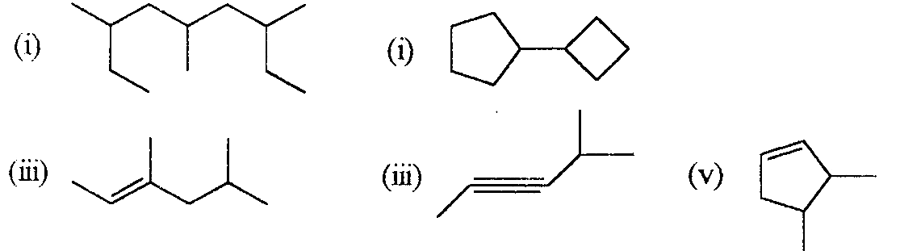
(b) Assign an ionic charge for four only of the indicated atoms in the following structures (All unshared valence electrons on these atoms are shown).
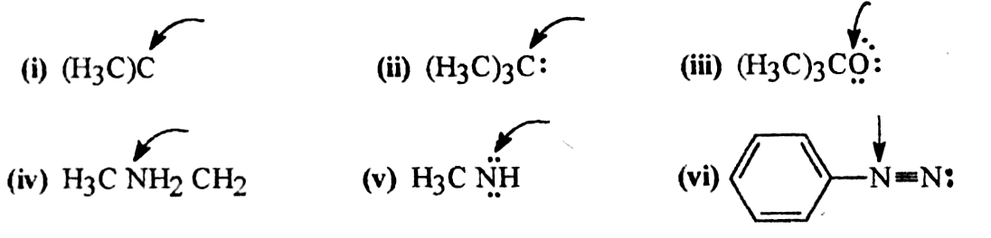
(c) What hybrid orbitals are used to form each of the indicated covalent bonds ?
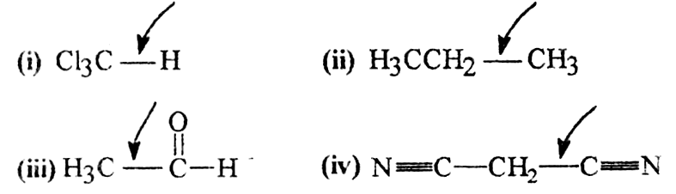
(d) Write structural formula for the missing reagent in eight of the following synthesis.
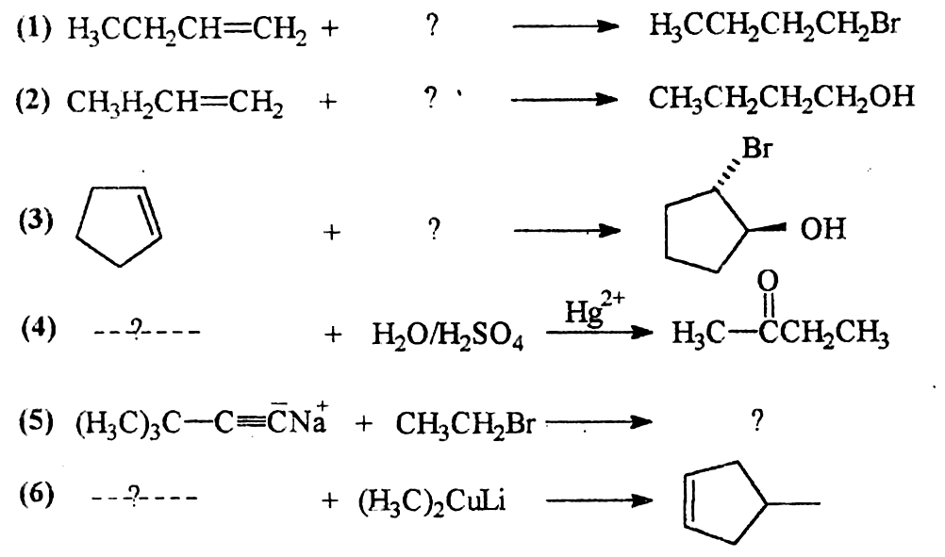
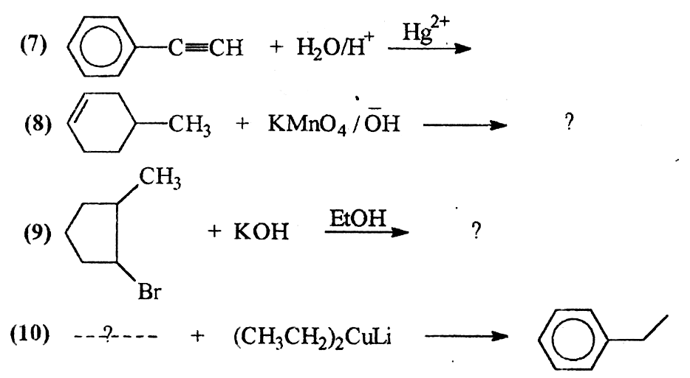
(Q 2) (a) Designate the Lewis acid and Lewis base in two of the following reactions.
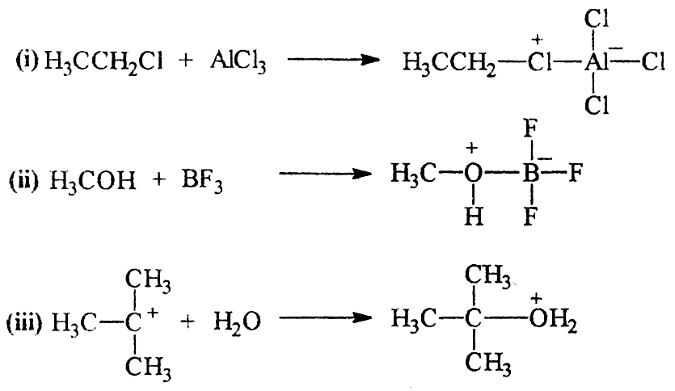
(b) Explain two of the following:
(i) Guanidine is strong base whereas phthalimide is sufficiently acidic to form alkali metal salts.
(ii) The nitrogen atom in pyrrolidine is basic whereas is not in pyrrole.
(iii) p-Nitroaniline is less basic than aniline itself.
(c) Predict the more stable alkene of each of the following pairs:
(i) 2-Methyl-2-pentene or 2,3-dimethyl-2-butene.
(ii) cis-3-hexene or trans-3-hexene.
(iii) I-hexene or cis 3-hexene.
(iv) trans 2-hexene or 2-methyl-2-pentene.
(d) Acid-catalyzed dehydration of neopentyl alcohol (H₃C)₃CCH₂OH, yields 2-methyl-2-butene as the major product. Outline acceptable mechanism showing all steps in its formation.
(Q 3) (a) Give the products that be formed when each of the following alcohols is subjected to acid-catalyzed dehydration. If more than one product would be formed, designate the alkene that would be the major product, (Neglect cis-trans isomerism).
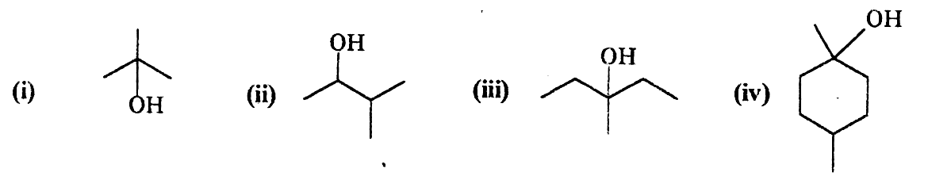
(b) Classify the following solvents as being protic or aprotic
formic acid, HCO-OH; acetone H₃C-CO-CH₃; acetonitrile CH₃C≡N; formamide H-CO-NH₂, sulfur dioxide, SO₂; ammonia, NH₃; trimethylamine, N(CH₃)₃; ethylene glycol HOCH₂CH₂OH.
(c) Write a formula for the expected rearranged carbocation, if any, from each of the following carbocations:
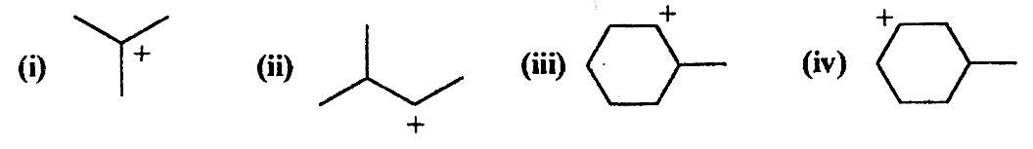
(d) Give a reason for two only of the following facts.
(i) Tertiary carbocations are more stable than secondary carbocations.
(ii) alkyl iodides are easily hydrolyzed then alkyl flourides.
(iii)Toluene is more reactive than benzene in electrophilic aromatic substitution reactions.
(Q 4) (a) Outline acceptable mechanism for one of the ionic additions of :
(i) HBr to 2-methyl-I-butene.
(ii) HI to I-methylcyclopentene.
(b) Write the general structure for two only of the alkenes that would produce the following products when treated with ozone and then with zinc and water.
(i) H₃C-CO-CH₃ and CH₃CH(CH₃)CHO
(ii) CH₃CH₂CHO only (2 mol are produced from 1 mol of alkene).
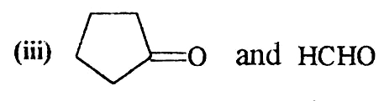
(c) Which member of each of the following pairs would you expect to be the more water soluble? Why? (answer two-only).
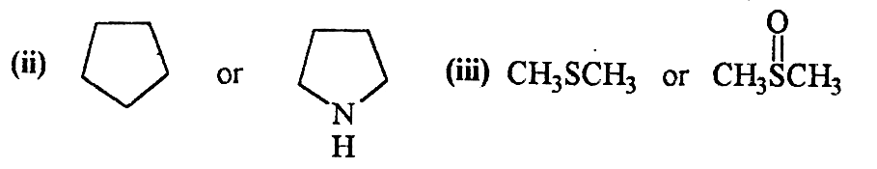
(d) Explain two only of the following findings.
(i) O-Nitrophenol and p-nitrophenol are more acidic than phenol itself.
(ii) 2,6-Dimethyl-N,N-dimethylaniline is inactive towards diazo coupling reactions whereas N,N-dimethylaniline is highly active.
(iii) O-Hydroxybenzoic acid (salicy1ic acid) is more acidic than m-hydroxybenzoic acid.
Good Luck
Prof. Dr. Maher El-Zohry
Assiut University Time allowed: 2 hrs
Faculty of Science Mar. 2008
Chemistry Department
Student Name:
Student No.

Mid-Term Organic Chemistry Examination for Pre-Pharmacy Students (Organic Chemistry)
Answer all the following questions:
Ql. For the following compound (10 Marks)
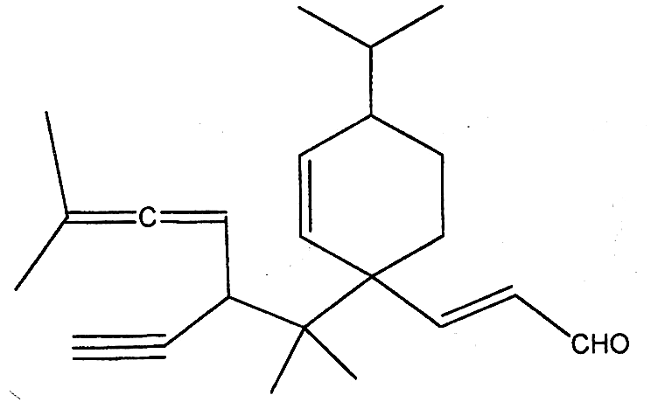
1- What is the compound type ?
2- What is the functional group ?
3- How many sp³ carbons ?
4- How many sp² carbons ?
5- How many sp carbons ?
6- How many sp² atoms ?
7- How many sp³-1s σ bonds ?
8- How many sp²-1s σ bonds ?
9- How many sp²-sp³ σ bonds ?
10- How many sp³-sp³ σ bonds ?
11- How many sp²-sp² σ bonds ?
12- How many sp-sp σ bonds ?
13- How many sp-sp² σ bonds ?
14- How many 1°ry carbons ?
15- How many 2°ry carbons ?
16- How many 3°ry carbons ?
17- How many 4°ry carbons ?
18- How many 1°ry hydrogens ?
19- How many 2°ry hydrogens ?
20- How many 3°ry hydrogens ?
Q2. Which of the following structures could be classified as electrophiles or nucleophiles ? (2 Marks)
FeCl₃ CH₃NH₂ BH₃ H₂O
Q3. What is the bond angle for the indicated atom in the following molecules ? (2 Marks)
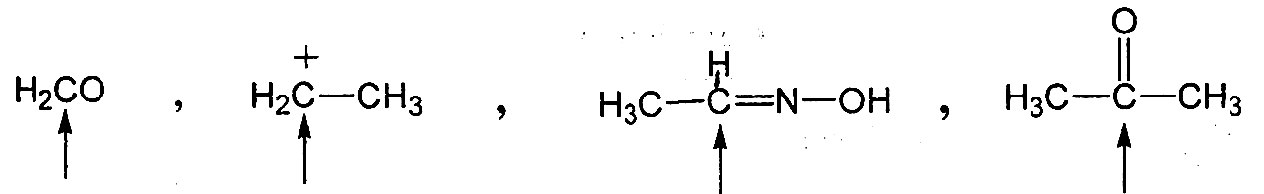
Q4. Which of the following pairs of structures represents tautomers?
2 Marks)
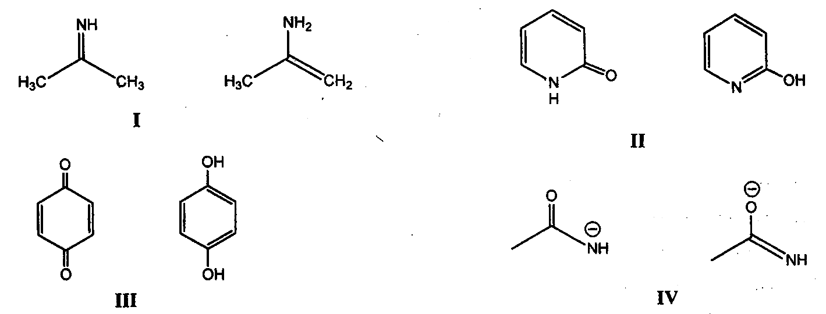
(i) I, II (ii) III, IV (iii) I, III (iv) II, IV
Q5. Which of the following compounds is nonpolar ? (2 Marks)
CH₃OH CS₂ NH₃ BF₃ CHCl₃
Q6. State whether each of the following disconnection is hemolytic or heterolytic ? (2 Marks)
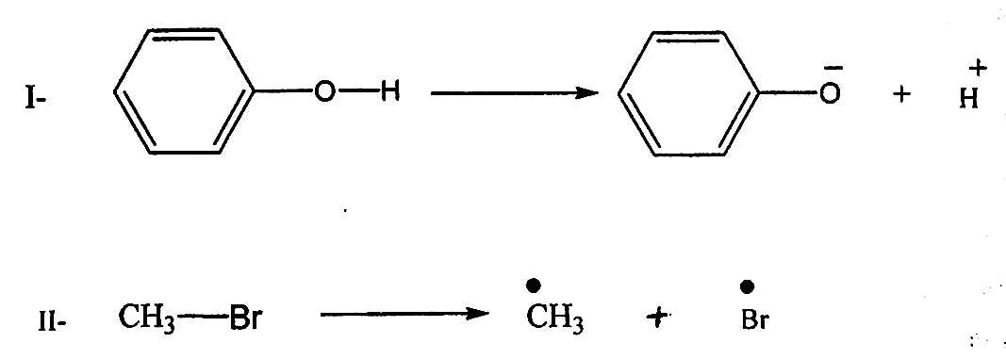
Q7. Arrange the following compounds in the order of increasing bond energy of the indicated bonds (least first) (2 Marks)
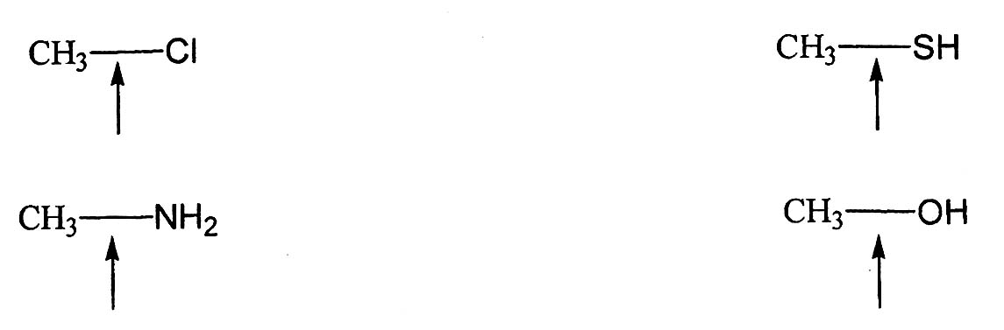
Q8. Give the type of organic reaction of the following and indicate the change of hybridization of atoms from the starting materials to the products ? (2 Marks)
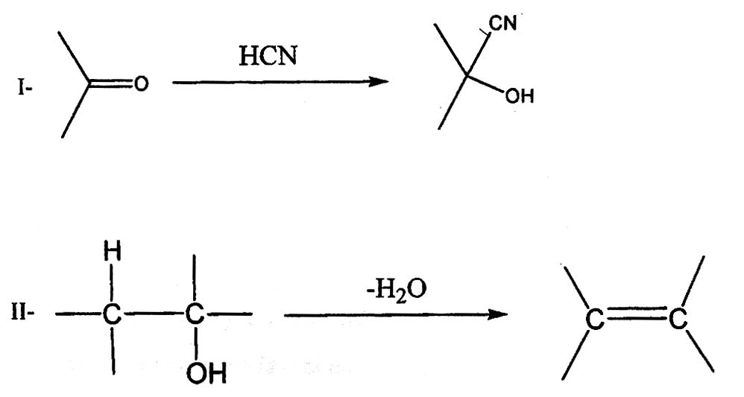
Q9. Designate Lewis acid and Lewis base in the following reactions ?
(2 Marks)
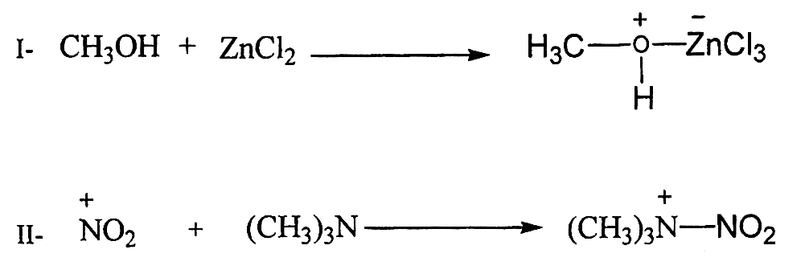

Good Luck
Prof. Dr. Maher El-Zohry

Assiut University Time allowed: 2 hrs.
Faculty of Science May 2008
Chemistry Department
Final Organic Chemistry Examination for Pre- Pharmacy student
Answer all the following questions:
Ql- Answer only four of the following items. (20 Marks)
(a)- Arrange the following compounds according to their acidity (5 Marks)
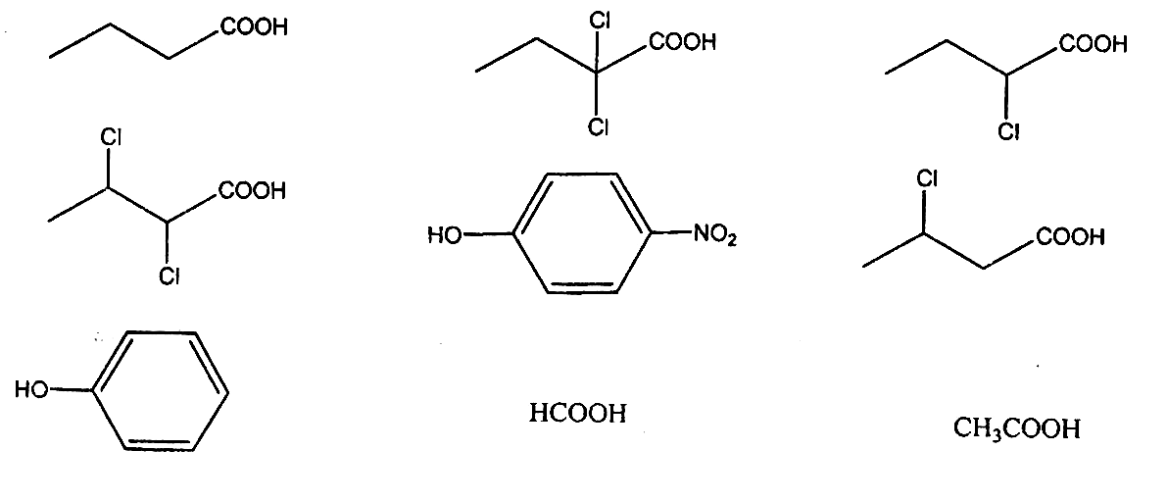
(b)- Explain why cyclohexyl amine is more basic than aniline whereas phenol is more acidic than methanol ? (5 Marks)
(c)- What is the product from the following reaction ? (5 Marks)
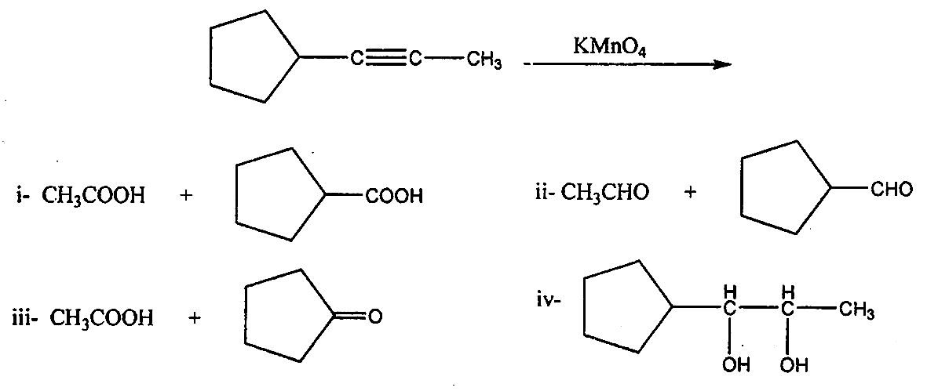
(d)- Predict the major organic product formed in each of the following reactions
(5 Marks)
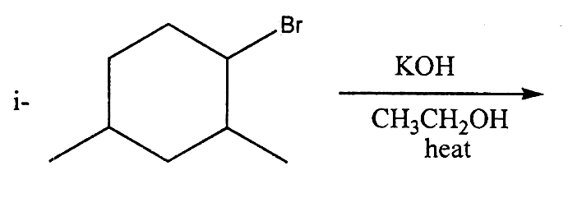
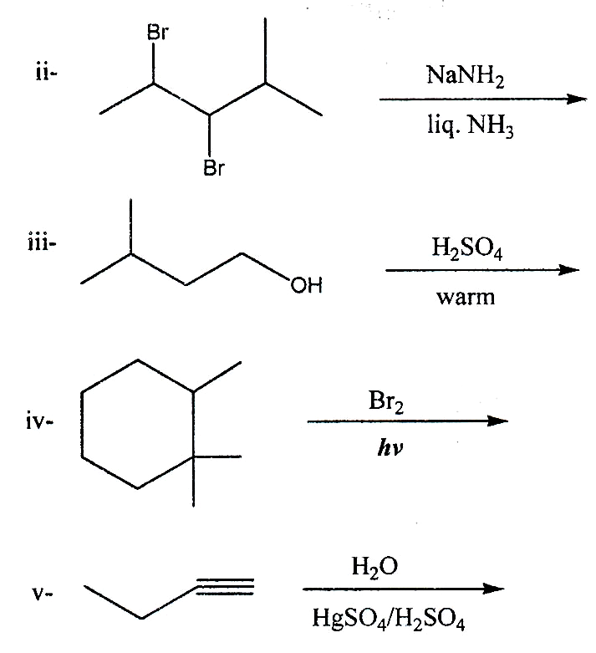
(e)- In the following five pairs of alkenes which is more stable and why?
(5 Marks)
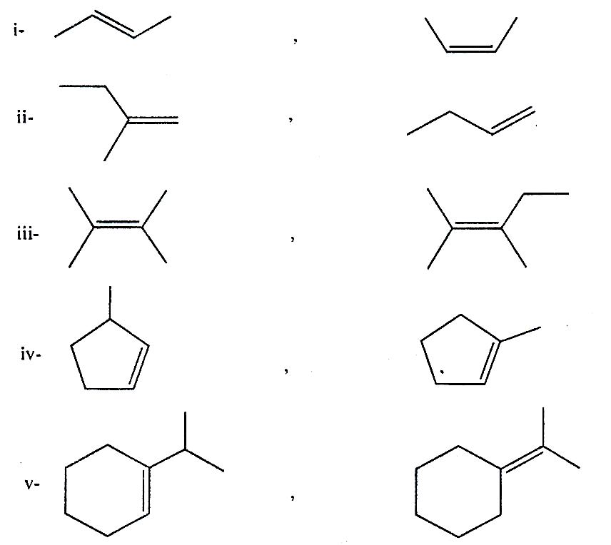
Q2- Answer only four of the following items (20 Marks)
(a)- Give the reason for guanidine is highly basic whereas phthalimide is sufficiently acidic to form alkali salts? (5 Marks)
(b)- Explain why methyl iodide is easily hydrolyzed than methyl fluoride in aqueous alkaline solutions? (5 Marks)
(c)- Show by equations the synthesis of trans-1,2-cyclohexandiol and cis-1,2-cyclohexandiol. (5 Marks)
(d)- Complete the following equation and write its reaction mechanism. (5 Marks)
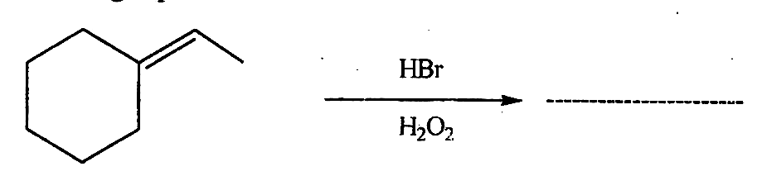
(e)- Arrange the following compounds in order to increasing bond distance of the indicated bonds (least first). (5 Marks)
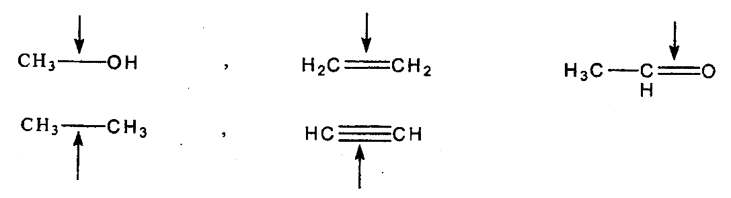
Q3- Answer only four of the following items. (20 Marks)
(a)- Explain why N,N-dimethylaniline is less basic than N,N-dimethyl-2,6-dimethylaniline? (5 Marks)
(b)- Give the reason for 1, I-dimethylethyl carbocation is more stable than I-methylethyl carbocation. (5 Marks)
(c)- Write the general structure of the alkenes that would produce the following products when treated with ozone and then with zinc and water. (5 Marks)
i- CH₃COCH₂CH₃ and CH₂O
ii- CH₃COCH₂CH₂CH₂CH₂CHO
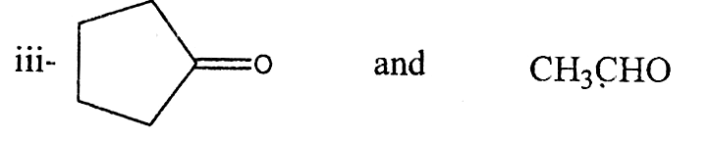
iv- CH₃COCH₃ only (2 moles are produced from one mole of alkene).
v- (CH₃)₂CHCHO and CH₃CH₂CHO
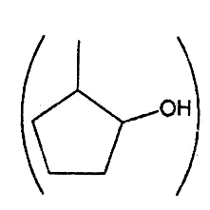

(d)- Acid catalyzed dehydration of either 2-methylcyclopentanol
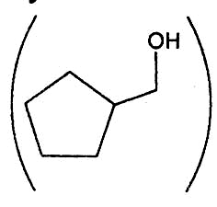

or cyclopentylmethanol give 1-methylcyclopentne as major products.
Write the possible mechanisms that explain these results (5 Marks)
(e)- Give the IUPAC nomenclature of the following compounds (5 Marks)
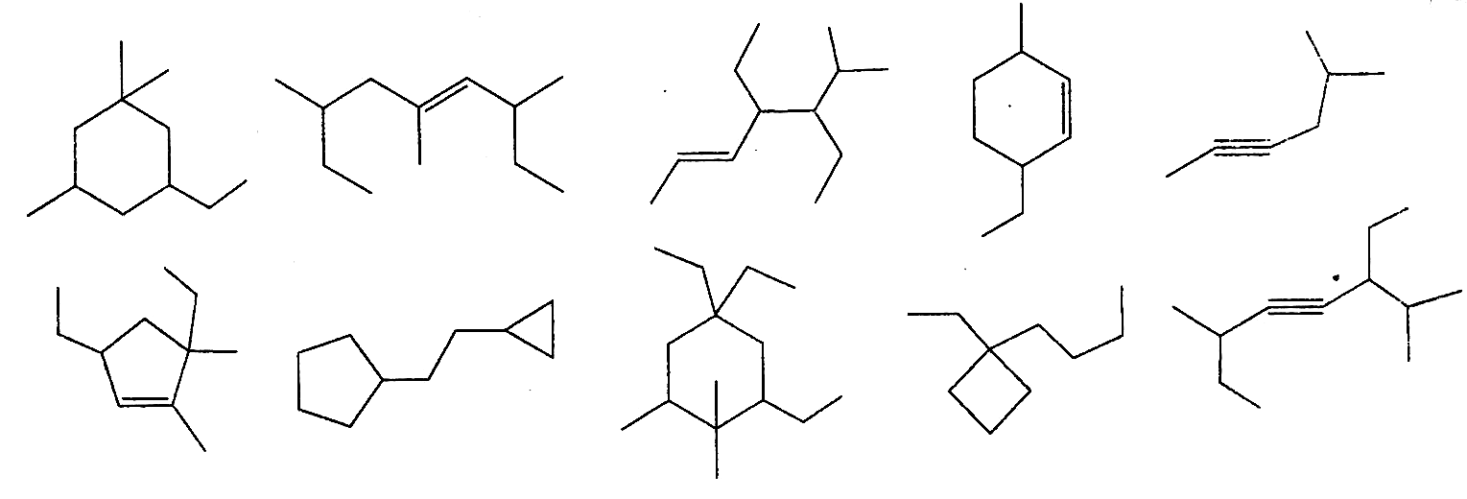
Q4- Answer only four of the following items. (20 Marks)
(a)- Outline the mechanism for the ionic addition of HBr to 1,3-dimethylcyclopentene. (5 Marks)
(b)- Give the reason for chlorobenzene is failed to hydrolysis to the corresponding phenol in aqueous alkaline medium. (5 Marks)
(c)- Predict the major organic product of the reaction of 2-methyl-2-butene with each of the following reagents. (5 Marks)
i- C₆H₅CO₃H ii- KMnO₄/⁻OH iii- BH₃/H₂O₂/⁻OH
iv- H₂O/H₂SO₄ v- Cl₂/CH₃OH
(d)- What are the best conditions for the following conversion ? (5 Marks)
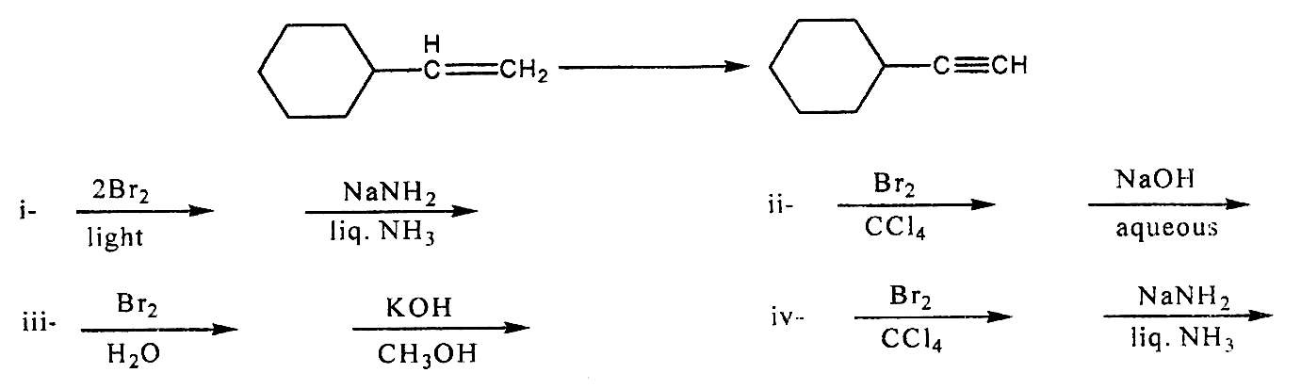
(e)- Which is the following compounds can exist as a pair of geometric isomer? Draw their structures and label them as cis and/or trans. (5 Marks)
i- ClCH₂-CH=CH-CH₂Cl ii- CH₃-CH=CH-COOH
iii- CH₂=C(CH₃)CH₂-CH₃ iv- HOOC-CH=CH-COOH
v- CH₃-CH₂-CH₂-CH₃

Good Luck
Prof. Dr. Maher El-Zohry
جامعة أسيوط فيزيـــــــــــاء العام الدراسي 2008/2007
كلية العـلــوم الفرقة: إعدادي صيدلــة
قسم الفيزياء الزمـن: ثلاث ساعات
Answer Only Five Questions: أجب عن خمسة أسئلة فقط مما يأتي:
ملحوظة هامة: الأسئلة علي ثلاث صفحات ، ويجب إجابة كل سؤال في صفحة منفصلة كم يجب إجابة السؤال كاملا وليس جزء من سؤال مع جزء من سؤال آخر مع مراعاة ترقيم إجابة الأسئلة حسب ترقيمها في ورقة الأسئلة.
Questions No. (1) and (2): Determine which of the following statement is correct [√] and which is not [X].
ضع إجابتك عن السؤال الأول والثاني في جدول رأسي يحتوي علي رقم الفقرة وقرارك:
Question No. (1): (30 Marks)
1- X-ray produced from the nucleus of atom.
2- The power of a thin lens is direct proportional to λ of light used.
3- The distance between two successive waves is called frequency.
4- Range of far U.V. radiation extends between 0.3 x 10⁻⁵ cm to 0.2 x 10⁻⁵ cm.
5- Continuous emission spectrum produced as a result of inward jumping of orbital electrons.
6- Astigmatic eye accompanied by myopia can improved by sphero-toric lens.
7- Ametropic eye whose near and far points are normal..
8- A thermaneous materials transmit far I.R.
9- Energy of electromagnetic radiations is direct proportional to its wave-length (λ).
10- Condition to disperse white light without it deviate is:
A_{l} (n_{l} - 1) = A₂ (n₂ - 1).
11- Cone nerves fibers on retina register colours.
12- Amplitude of Accommodation equals to power of Accommodation.
13- A = 5 X 10⁻⁵ cm has the dual character of visible light and I.R.
14- If the length of a small object is longer than A. of light source used, it can scatter the incident light on it.
15- Focal length for red colour is shorter than that for violet colour
Question No. (2): (30 Marks)
1- Emmetropic eye whose near and far points are normal.
2- Diathermaneous materials transmit far I.R.
3- V.V. spectrometer has greater dispersive power than normal one (visible spectrometer).
4- Condition for achromatism is [n_{v} - n _{r}]₁ A_{l} = [n_{v} - n_{r} ] A₂.
5- If the magnification is negative (-ve) image is inverted U.V.
6- λ for orange colour is longer than Indigo colour.
7- U.V. radiations can ionize gaseous materials.
8- A diverging-cylindrical lens needed to improve myopic eye accompanied by astigmatism.
9- Image of vertical slit source formed by toric lens is vertical sharp line and pale rectangular at different distances.
10- Range of near I.R. extends between λ = 5 X 10⁻⁵ cm. to λ = 15 x10⁻⁵ cm.
11- The refractive index is direct proportional to λ.
12- Continuous emission spectrum produced by heating an element to red-hot temperature.
13- 60% of the total solar energy is due U.V.-radiations.
14- Hypermetropia is due to increase in eye-ball dimension.
15- Scattering of electromagnetic radiations increases by increasing frequency.
Question No. (3): (30 Marks)
(a) Explain how to produce X-rays, and explain the difference between characteristic X-rays and continuous X-rays. (15 Marks)
(b) The potential difference across X-ray tube is 100000 volts and the current through it is 5 mA. Calculate the maximum speed of cathode rays produced, and the rate of production of heat at the target if only 0.1 of the energy is converted into X-ray radiation (15 Marks)
Question No. (4): (30 Marks)
أكتب إجابتك بنفس الترتيب في جدول رأسي يحتوي علي رقم العبارة والحرف الأبجدي المناسب.
1- Kirchhoff's voltage says:
(a) Σ I = 0 | (b) Σ E = Σ I R | (c) Σ E = Σ I² R | (d) Σ E = Σ IV
2- The force on a current-carring wire in uniform magnetic field is given by:
(a) F = B L A | (b) F = F L I | (c) F = L B ν | (d) F = B L V
3- An a.c. current equation is given by 15 sin 3 t, therefore, the current after 30 ses. Is
(a) 9.61 A | (b) 15 A | (c) 13.36 A | (d) 12.61 A
4- The amplitude of T-wave, in E.C.G., is increased in:
(a) Hypoxia | (b) Hyperthyroidism | (c) Hypertrophy | (d) Toxic dses
5- A voltage 50V is applied across a 5 ohm in 20 sec., ∴ the average energy dissipated in R is:
(a) 100 J | (b) 10000 J | (c) 1000 J | (d) 5000 J
6- The NMR is used to study the change in the concentration of:
(a) proteins | (b) ATP | (c) EPR | (d) pH
7- The calculated Nernst potential is the potential across:
(a) The neutral lipids | (b) the membrane | (c) the protein | (d) the H₂O ions
8- The EMG may be obtained from:
(a) muscles | (b) neurons | (c) brain | (d) membrane
9- In a purely capacitive circuit, the power factor cos φ is equal to:
(a) zero | (b) 1 /  | (c) one | (d) 0.5
10- Pure germanium doped with arsenic will transfer germanium to semi-conductor type:
(a) n-type | (b) p-type | (c) np-type | (d) q-type
11- The conservation of energy requires that all radiations from human bodies be at the expense of:
(a) internal energy | (b) outside  environment | (c) outside  temperature | (d) external energy
12- The semi-conductor n-p-n transistor, the emitter-base junction is connected:
(a) Forward bias | (b) Reverse bias | (c) Internal bias | (d) Outside bias
13- The first law of thermodynamic is expressed in the form:
(a) ΔE= ΔQ + ΔW | (b) ΔQ= ΔE + ΔW | (c) ΔW= ΔE +ΔQ | (d) ΔQ= ΔE + ΔF
14- The heat capacity C_{v} of a system at constant volume is related to the specific heat c_{v} by:
(a) C_{v}= c_{v} m | (b) C_{v} = c_{v} n | (c) C_{v} = c_{v} nm | (d) C_{v} = c_{v} E
15- The velocity of sound waves in Muscles are:
(a) 1540 ms⁻¹ | (b) 1410 ms⁻¹ | (c) 1750 ms⁻¹ | (d) 440 ms⁻¹
Question No. (5): Put [√] for the correct statements and [X] for the others: (30 Marks)
أكتب إجابتك بنفس الترتيب في جدول رأسي يحتوي علي رقم العبارة والعلامة المناسبة:
1- The ECG apparatus is mainly a sensitive voltmeter.
2- Heating muscles by short wave using capacitor technique is due to oscillating magnetic field.
3- The EMG of a patient having myasthenia gravies shows that in repetitive stimulation the motor nerve to muscle transmission succeeded
4- Sensory neurons transmit signals from CNS to the muscles.
5- In synaptic conduction, the transmission is electrical assisted.
6- Heating by Ultrasonic waves, is due polarization of water dipoles of the body's molecules.
7- Heating muscles by short wave diathermy, using Ultrasonic method is by eddy currents.
8- A p-type semiconductor is produced by Germanium doped with Gallium.
9- The transistor is a current-controlled device.
10- The function of S.A. node is to generate and initiate the cardiac rhythm.
11- The RC of a resistor-capacitor circuit is referred to as the time constant of the circuit and has unit of ohm.
12- The sodium pump is referred to the moving of the sodium ions out of the membrane cells.
13- The junction between a nerve fiber is often called myoneural junction.
14- Excessive heating of humans tissue causes reddening and sometimes edema.
15- The energy necessary to vaporize one gram of water at 37° C is 2.4 KJ/g
Question No. (6): Solve The Following Problems. Put your decision answer in a vertical Table (30 Marks)
1- A gas in a cylinder is at a pressure of 8000 Pa and a piston has an area of 0.1 m² blocking the gas. Heat is slowly added to the gas, the piston is pushed up a distance (d) of 4.0 cm. Therefore the work done on the surroundings by expanding the gas (assume that pressure remains constant): (10 Marks)
(a) 52 J | (b) 42 J | (c) 32 J | (d) 35 J

2- A 150 µ F capacitor is made with two parallel plates 5 cm² in area each, separated by 0.5 mm thick sheet of biological material. Therefore, the dielectric constant of the biological material is: (10 Marks)
(a) 18.9 | (b) 16.9 | (c) 15.9 | (d) 17.8

3- An a.c. voltage E_{l} has r.m.s value of 10 Volts at a frequency of 1000 Hz is applied across a capacitance of 0.05 µF and a non-inductive resistor. If the output voltage across the capacitor E₂ is to have an r.m.s value of 7.5 Volts. Therefore the value of the resistor is: (10 Marks)
(a) 1.8 K Ω | (b) 2.8 K Ω | (c) 2.5 K Ω | (d) 2.4 K Ω
أسماء السادة الأساتذة الممتحنين: أ.د./ عبد الله ابراهيم عبد المجيد
أ.د./ عادل عباس محمد
GOOD LUCK
Faculty of medicine Date: 15-6-2008
Histology Department Time:3 hours(Histology&Anatomy)
-------------------------------------------------------------------------------------------------------
FINAL HISTOLOGY EXAM.
FOR
THE PREP. YEAR PHARMACY STUDENTS.
-------------------------------------------------------------------

Answer the following questions illustrating your answers with diagrams whenever possible:

1- Write an account on the structure of lymphatic nodule.
(5 marks)

2- Discuss the structure of Juxta glomerular apparatus.
(10 marks)

3- Describe the structure of mature Graffian follicle.
(10 marks)

4- Give an account on the structure of adrenal cortex.
(10 marks)

5- Write short note on the structure and function of Sertoli cell.
(10 marks)

6- Give an account on different types of liver lobules.
(10 marks)

7- Draw a labeled diagram of the great alveolar cell(E.M).
(5 marks)

--------------------------------------------
Good luck

Assiut University
Faculty of Medicine Time: 3 hours
Anatomy Department Date: 15 / 6 / 2008

Anatomy Examination
For Prep. Year Faculty of Pharmacy

Answer the following questions:

1. Describe with a diagram the anatomy of the female genital system.
(20 Marks)
2. Describe with a diagram the structure of the digestive tube.
(20 Marks)
3. Describe with a diagram the structure of the heart and the great vessels connected with it. (20 Marks)

Good Luck

بسم الله الرحمن الرحيم
Assiut University
Faculty of Pharmacy
Pharmaceutics Department
Prepharmacy Year
Introduction to Pharmacy
(Maximum Points: 80)
Time allowed: 2 Hours Thursday June 19, 2008
All Questions Should be Answered
ملحوظات : ورقة الأسئلة تتكون من صفحتين – يجب إحابة كل سؤال فى صفحة أو صفحات منفصلة- كما يجب احابة السؤال كاملا وليس جزء من سؤال مع جزء من سؤال آخر- مع مراعاة ترقيم إجابة الأسئلة حسب ترقيمها فى ورقة الأسئلة
اقرأ الأسئلة جيدا قبل الإجابة عليه
1.Give definition for the following: (15 points)
A-Pharmacy B- Enemas C-Glycerites
D-Code of ethics E- Textbooks
2. Write about the following: (12 points)
A- Label information of the OTC products
B- Semisolid dosage forms
C-Auxiliary labels
D-Hospital medication orders
3-Give Reason(s) for the following: (9 points)
A-Sometimes oral dosage forms is not suitable for administration
B-A pharmacist should always strive to perfect and enlarge his Professional Knowledge
C-It is particularly important to speak to the doctor before buying Over-the-counter drugs for children and elders.
4-Mention each of the following: (12 points)
A-Role of the pharmacists in community pharmacy
B-Requirements for the rational use of drugs
C-Role of the pharmacists in child health
5.Give the difference(s) between each of the following: (12 points)
A-Local and systemic effects
B-Tablets and cepsules
C-Brand and generic names of drug products
D-Gargles and mouth washes

ملحوظة: بقية الأسئلة فى الصفحة التالية

تاريخ الصيدلة
6. أحب عن الأسئلة التالية: (20 درجة)
أ-أذكر أهم فوائد دراسة تاريخ الصيدلة
ب-تكلم عن ما تضمنته بردية (قرطاس) برلين
ت-تناول بالشرح مراحل تطور الدواء وصناعته فى مصر الحديثة
ث- وضح الدور الذى لعبته مدرسة جامعة الإسكندرية كأحد المدارس الطبية فى مصر القديمة

مع أطيب التمنيات بالتوفيق

يعقد امتحان الشفوى بقسم الصيدلانيات بعد الامتحان التحريرى مباشرة

كلية التربية الزمن:-ساعتان
قسم علم النفس الفرقة: إعدادى صيدلة
***** المادة: علم نفس
امتحان الفصل الدراسى الثانى للعام الجامعى 2007/2008 م
************************************************************
أجب عن الأسئلة التالية:
السوال الأول:
" إن حياة الانسان لاتمضى على وتيرة واحدة ، وإنما هى فى العادة مليئة بالخبرات والتجارب المتنوعة" ناقش ذلك موضحا.
1- تعريف الإنفعال وشروط حدوثه. (9 درجات)
2- كيف تتكون العواطف وما هى أنواعها. (8 درجات)
السؤال الثانى:-
"يولد الإنسان وهو مزود بالاستعدادات التى تجعل فيه كائنا اجتماعيا قادرا على التكيف مع البيئة الاجتماعية" ناقش ذلك موضحا.
1- العوامل المؤثرة على عملية التذكر. (9 درجات)
2- أنواع التفكير علىأساس مستوى التفكير. (8 درجات)
السؤال الثالث:-
ناقش مايلى.
1- الأثار النفسية المترتبة على الإدمان. (8 درجات)
2- النمو اللغوى والعقلى فى مرحلة الطفولة. (8 درجات)
***************انتهت الأسئلة *******************مع أطيب التمنيات بالنجاح
د/ صمويل تامر بشري

